**Work Basket/Work Queue:**

**Routing to Work basket executes a Predefined activity: ToWorkBasket**

**When we route to Workbasket  data gets inserted to table: pc_assign_workbasket**

**Relation b/w Work Group, Work Queue & Operator:**

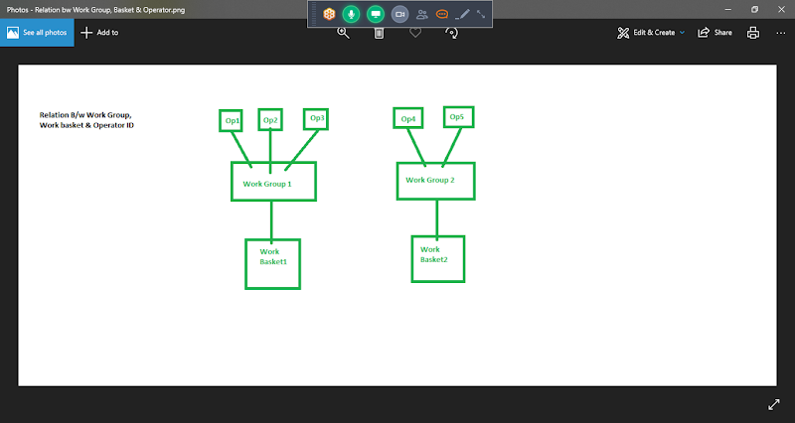

**Work Group1 = Team 1 ( Op1, Op2, Op3)**

**Work Group2 = Team2 ( Op4, Op5)**

**Working with Work Group & Work Basket**

**Work Group-> Team of Operators**

**Team1- 5 dev**

**Team2- 8 dev**

**Work Group-> Work Queue**

**Create Operators ( Manager Access) (2), Work Group(1) & Work Queue(1)**

**- Define relation b/w Work Group & Work Queue & Work Queue & Work Group**

**- For Each Operator Define the Work Group Relation**

**-**

**First Create Work Group:**

**Open default work group from operator Rule form=>  Go to Work Tab:**

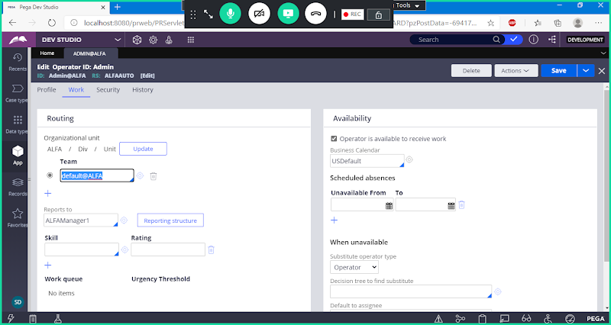

**Open Default Work Group & Use Save as ->**

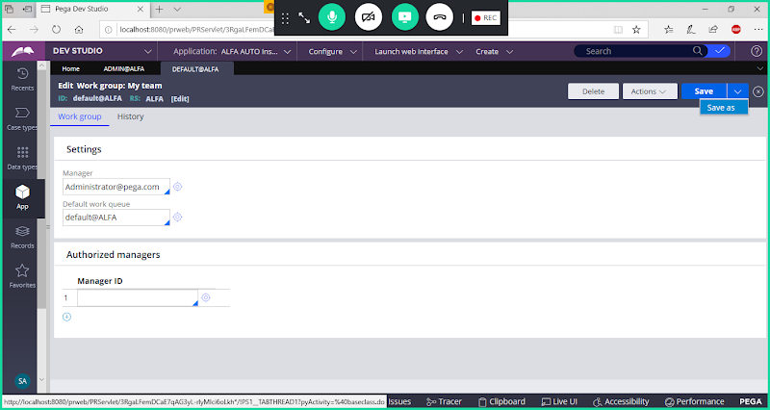

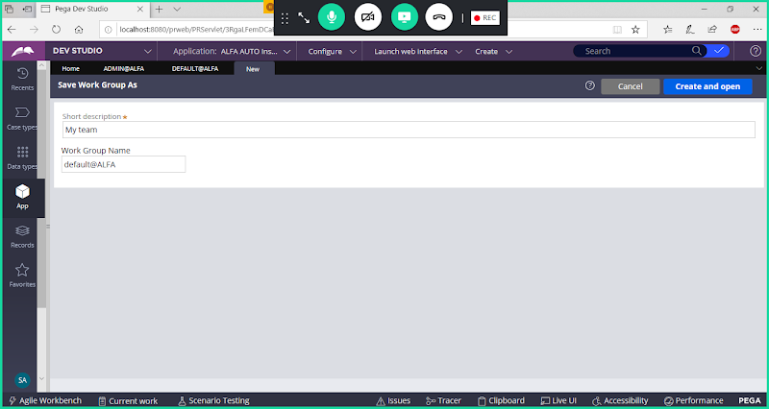

**Change Work Group Name**

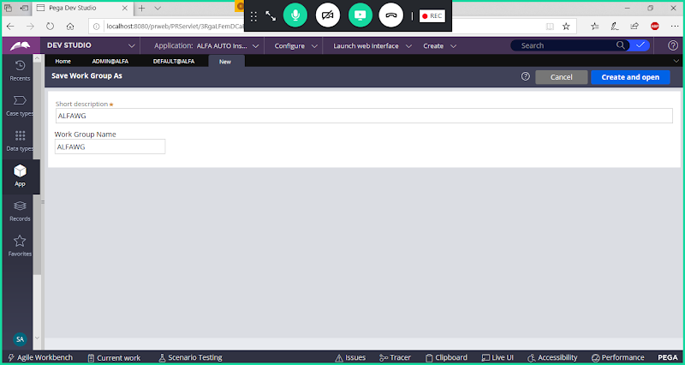

**Open**

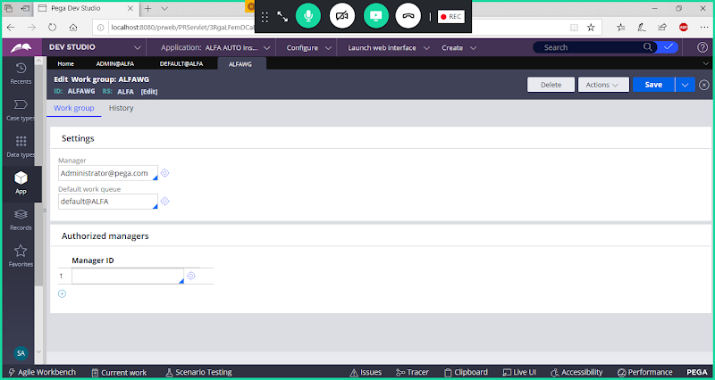

**Save Work Group**

**Create Work Queue from default Work queue:**

**From Above Work Group Rule form -> Open Default Work Queue**

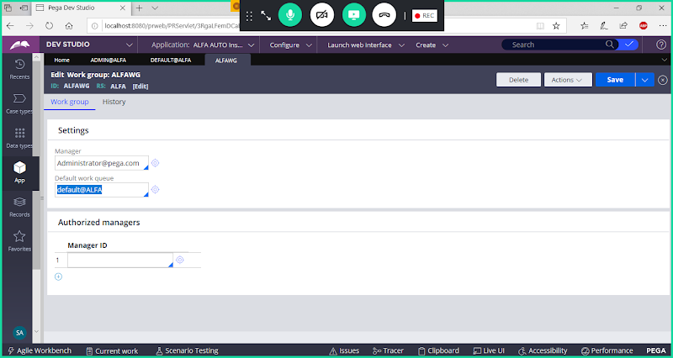

**Open Default Work Queue:**

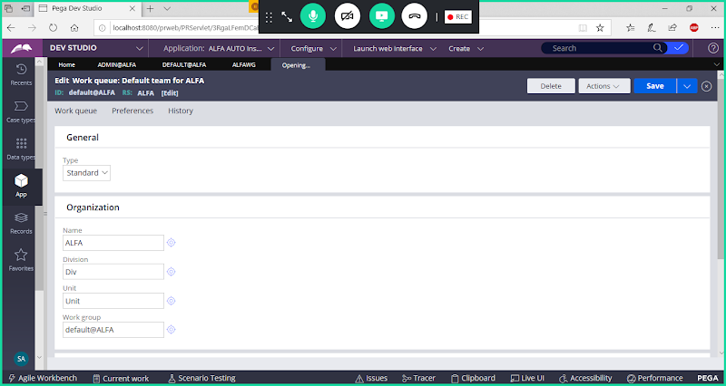

**Use saveas**

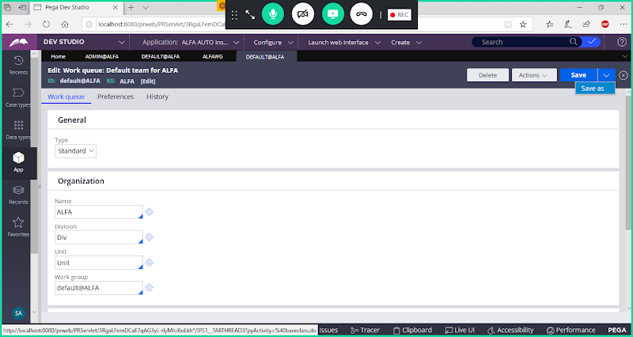

**Update Work Queue Name**

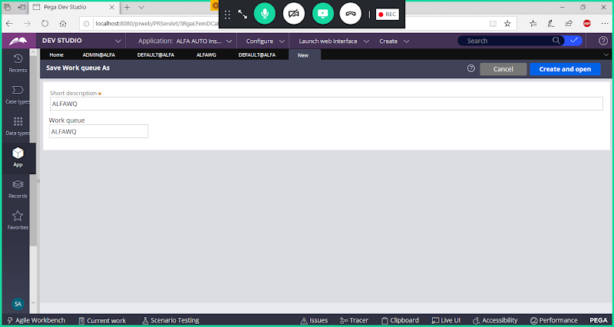

**open**

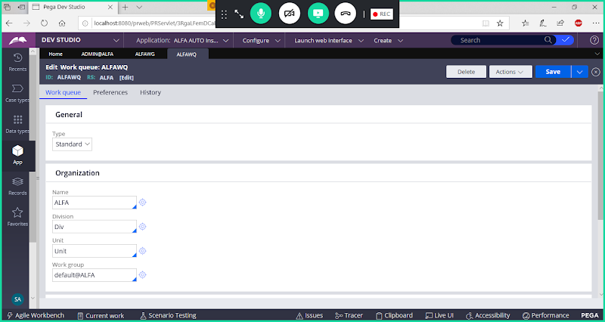

**Save Work Queue / Work Basket**

**Map Basket/Work Queue to WorkGroup**

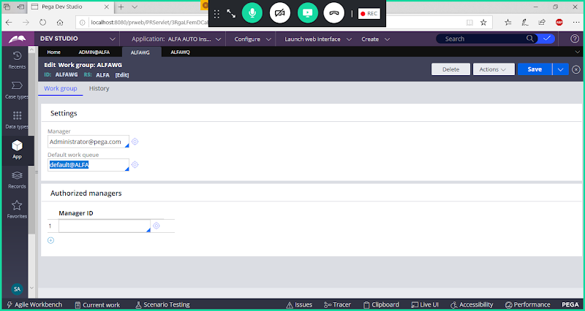

**Delete Queue & Add New Work Queue**

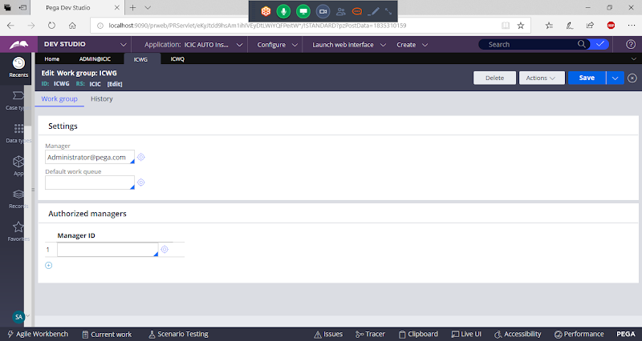

**Call  Work Queue name**

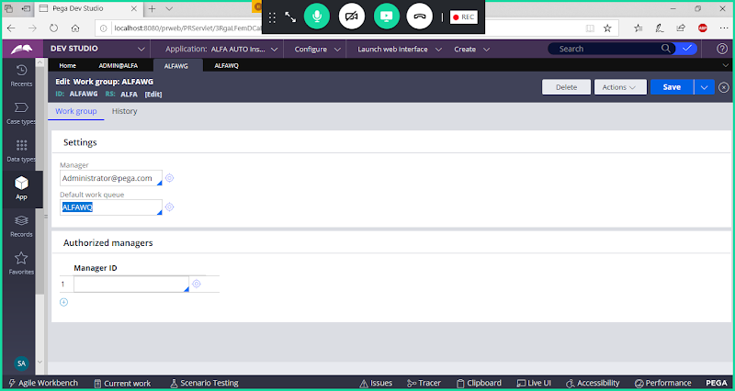

**Save Work Group**

**Map Work Group to Work Queue:**

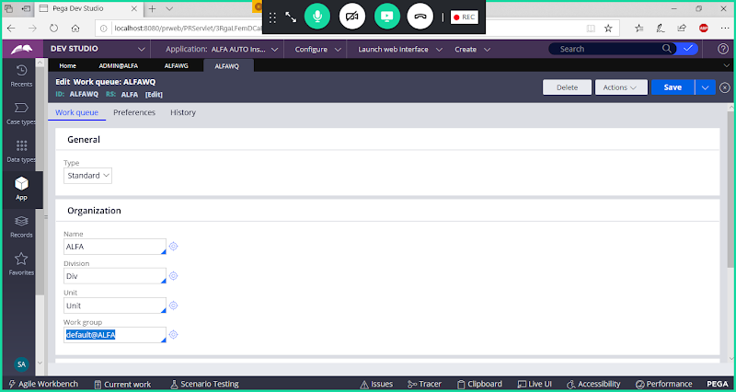

**Remove Default WOrk Group Name**

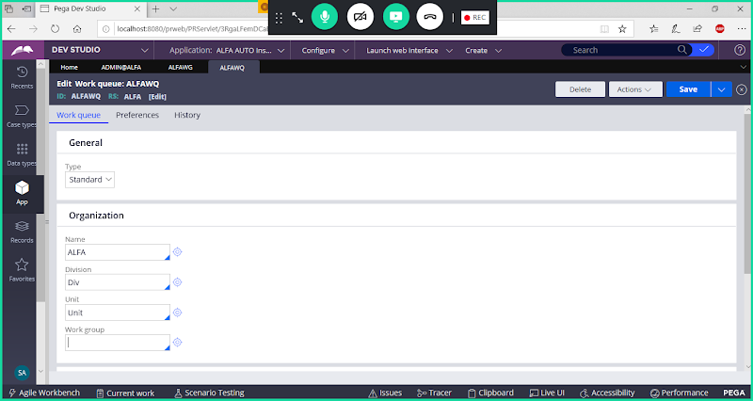

**Add Work Group Name**

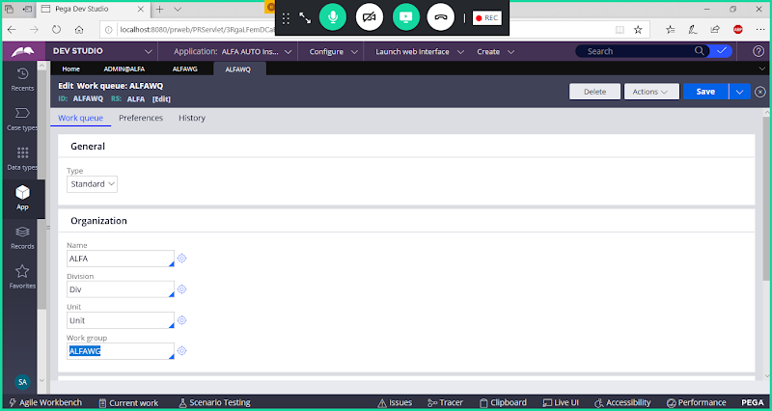

**Save Work Queue**

**Open Existing Manager Operator id's & Assign Work Group:**

**Open Manager ID: ALFAManager1 & ALFAManager2**

**To Open Manager Id's Go to Records Explorer-> Organization-> Operator ID**

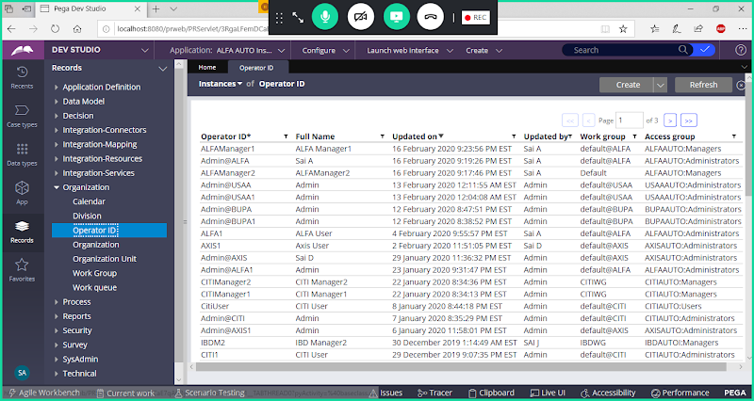

**Open Both Id's & Go to Work Tab**

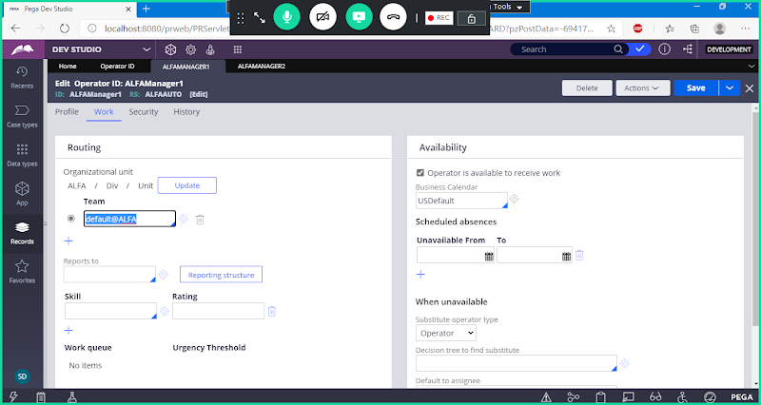

**Remove default Work Group & add new work group name**

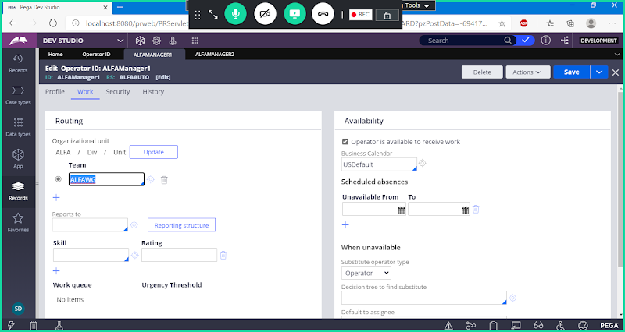

**Now Save Operator ID**

**Do Same thing for 2nd ManagerID**

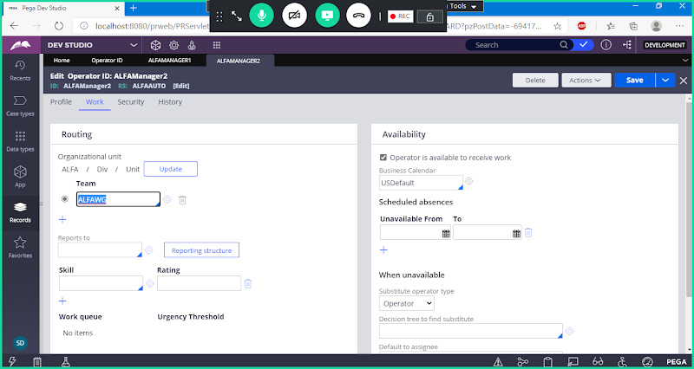

**Save Operator ID**

**===============**

**Req: Add New assignment to capture loss details of vehicle**

**Create Single Value Properties:**

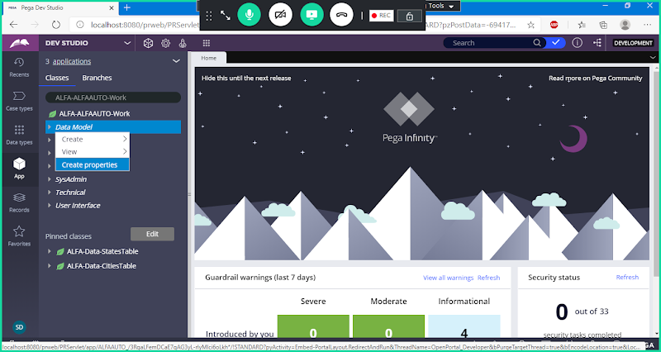

**Loss Type**

**VehicleType**

**LossAmount**

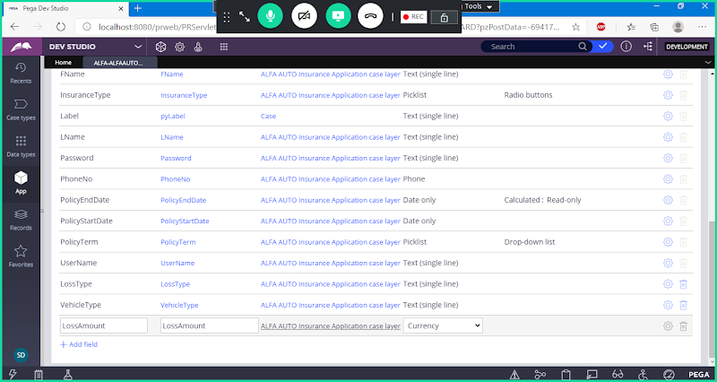

**Create Section:**

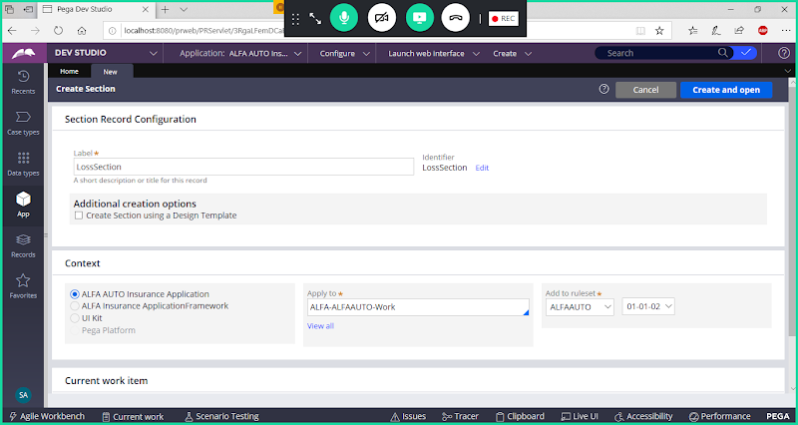

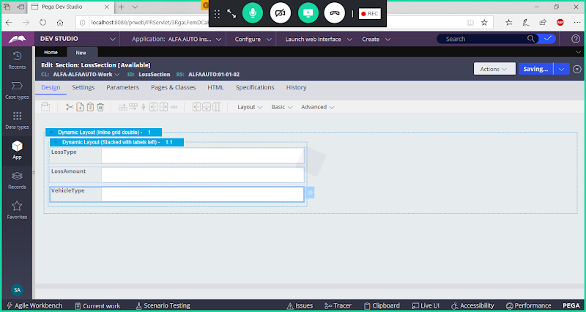

**Create Flowaction:**

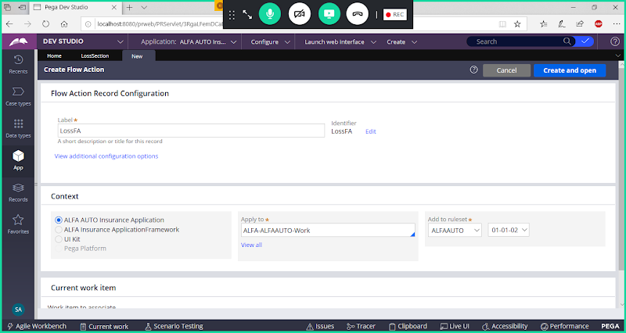

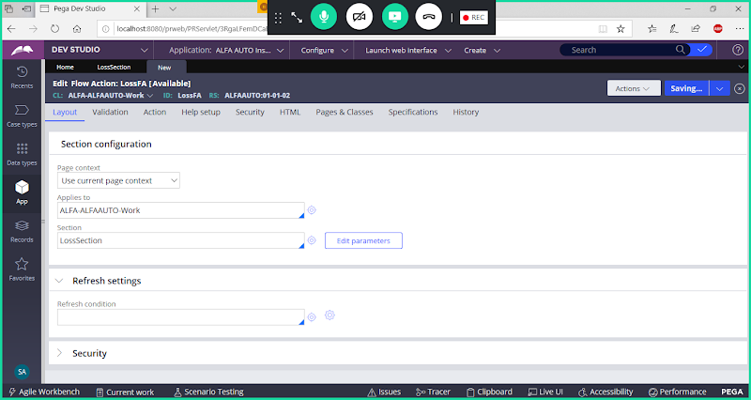

**Save**

**Open Insurance Flow:**

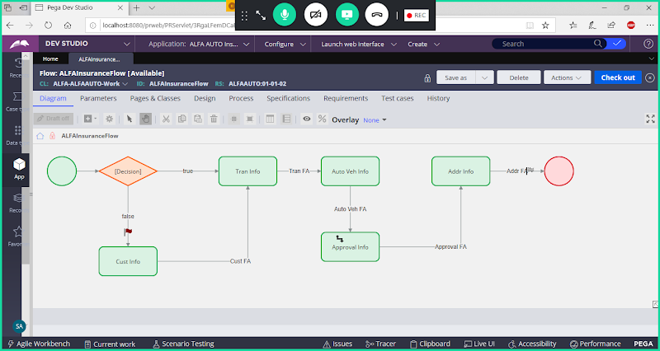

**Add New Assignment after Auto Details Assignment:**

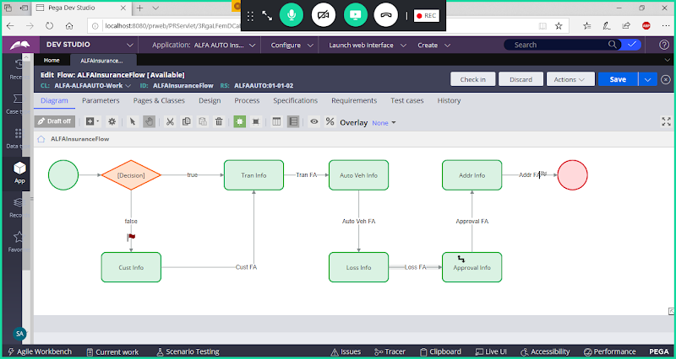

**Add Routing for Loss Details Assignment**

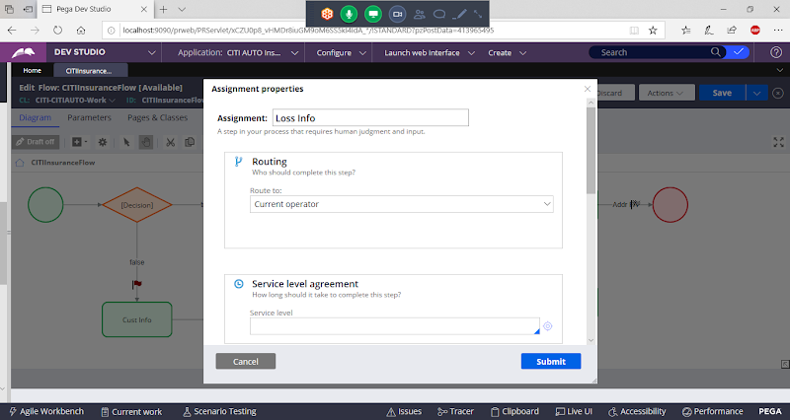

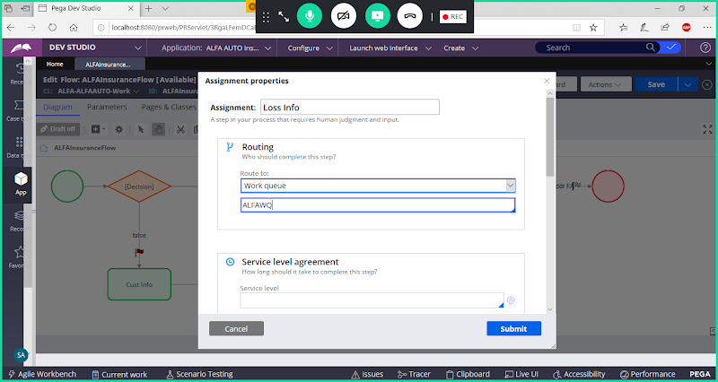

**or**

**Select Custom**

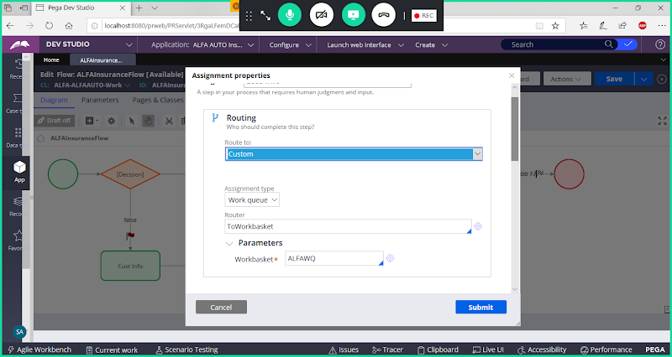

**Submit & Save Flow & Run the Flow**

**After Submitting Vehicle Details Loss Details from will be routed to Work Queue.**

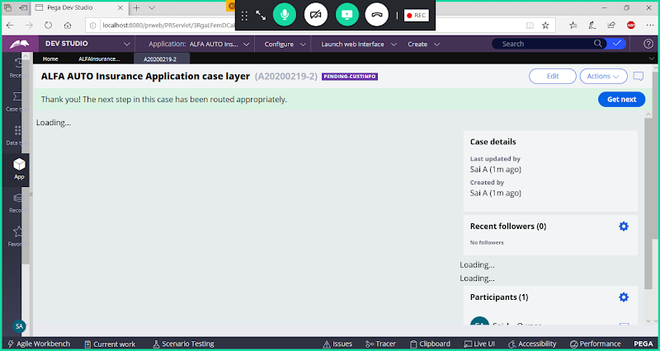

**Login Using  any one manager ID**

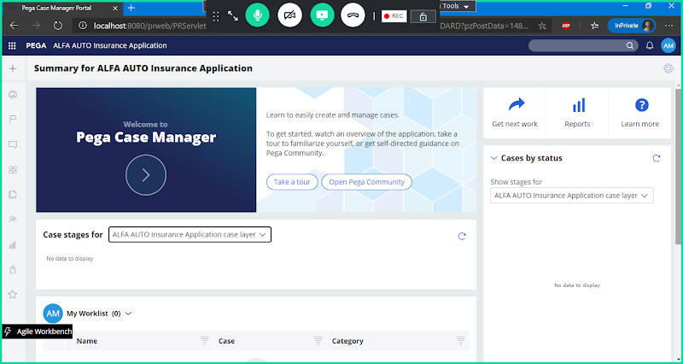

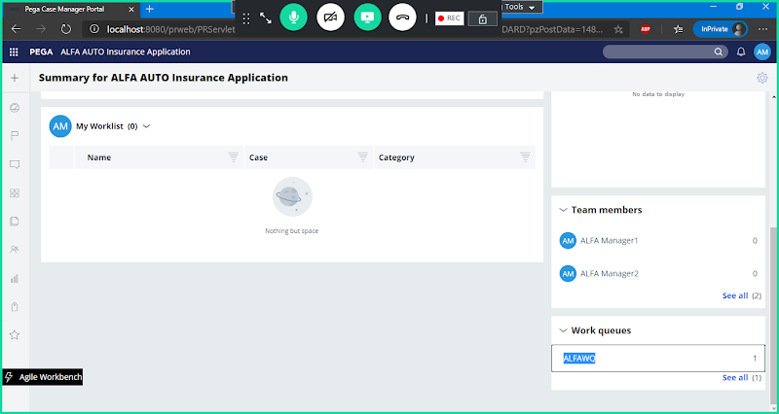

**Click on Your Work Queue**

**Other Team Members in Queue also can See the Same Work Item, but any one operator only can complete the Work Item with in the Team.**

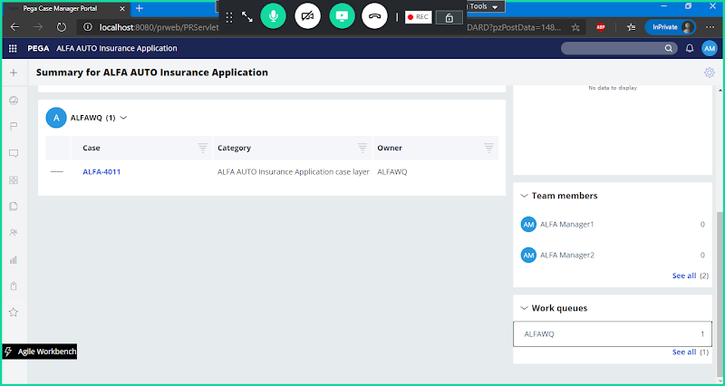

**Click on Work Item & Process**

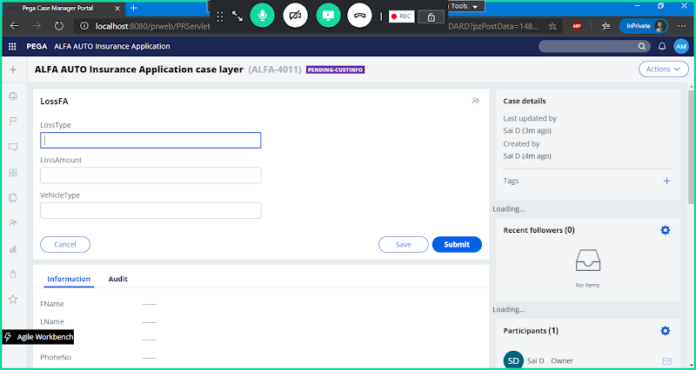

**Once we Submit workitem will be removed from the Work queue.**

**Transferring or Rerouting Work Items:**

**Open Manager Portal from Launch  Web Interface:**

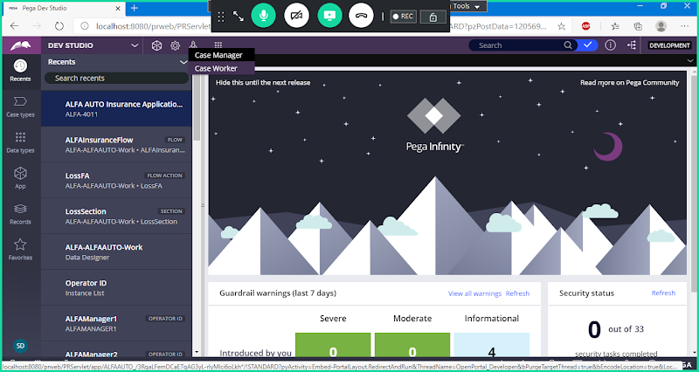

**Operator Menu-> Bulk Actions**

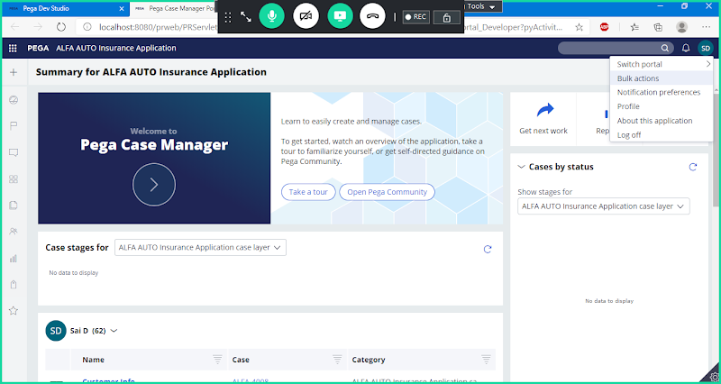

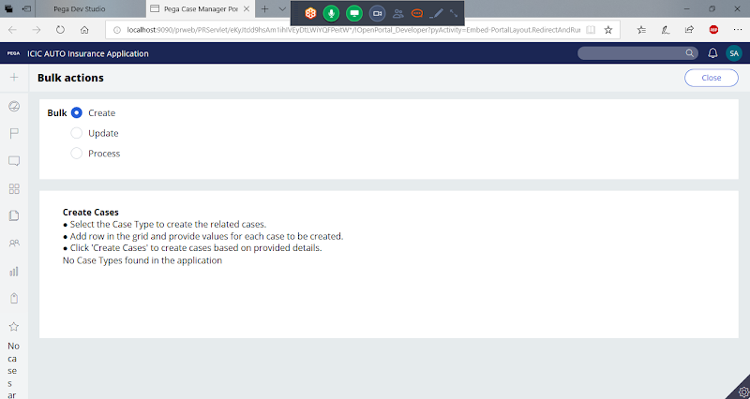

**Click on Process**

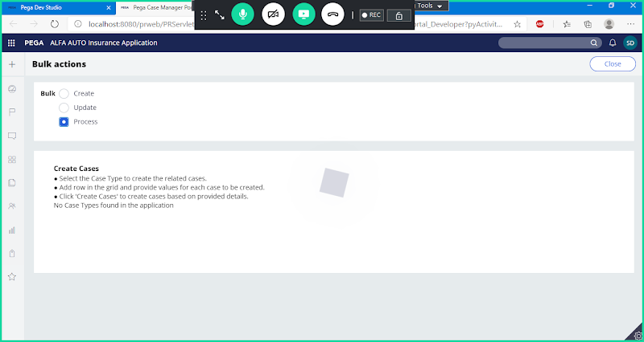

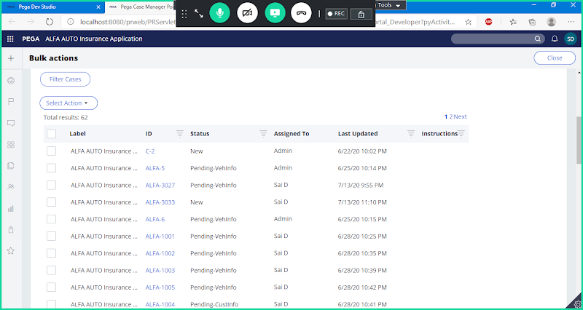

**Select Any one Work Item ->Click on Select Action**

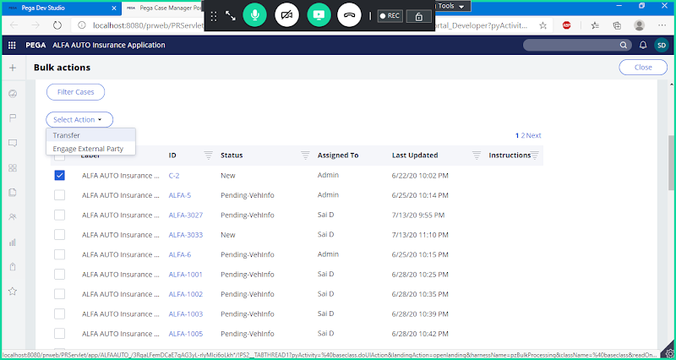

**Select Transfer from Action Dropdown**

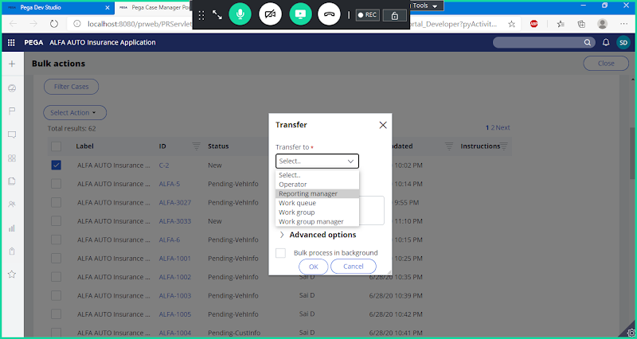

**Select Transfer**

**=======**